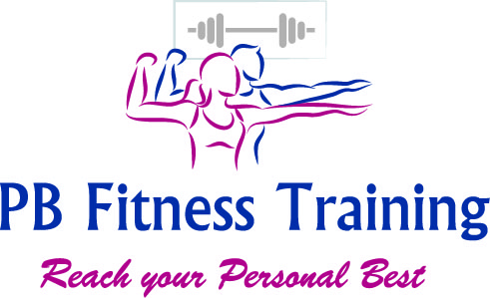

PHYSICAL ACTIVITY HEALTH QUESTIONNAIRE
Personal Details
Title: ____________ Forename: ___________________________________
Surname: ________________________________________________________________________
Date of Birth: __ __ / __ __ / __ __
Emergancy Contact Name & Number __________________________________________________
Address ________________________________________________________________________
Town: _____________________ County: _____________________________________
Postcode: __ __ __ __ - __ __ __ Email: ______________________________________
Home: _____________________ Mobile: ______________________________________
Facebook ___________________Instagram_______________________________
Medical Questions
Do you currently or have you ever suffered from any of the following conditions?
1) Has your doctor ever said that you have a heart condition and recommended only medically supervised activity? Yes □ No □ More Info _______________________
2) Do you have any chest pains brought on by physical activity? Yes □ No □ More Info _______________________

3) Have you developed any chest pains in the last month? Yes □ No □ More Info _______________________

4) Has your doctor ever recommended medication for your blood pressure or heart condition?
Yes □ No □ More Info _______________________
5) Do you have a bone or joint problem that could be aggravated by the proposed physical activity?
Yes □ No □ More Info _______________________
6) Do you tend to lose consciousness or fall over as a result of dizziness?
Yes □ No □ More Info _______________________
7) Currently pregnant or recently given birth (If so - how far Post birth are you?)?
Yes □ No □ More Info _______________________
Health History
Do you currently receive medical care or do any of the following affect you?
8) Headaches or migraines? Yes □ No □ More Info _______________________
9) Have you recently had surgery? Yes □ No □ More Info _______________________
10) Currently being prescribed medication? Yes □ No □ More Info _______________________
11) Recently finished a course of medication? Yes □ No □ More Info _______________________
12) Diabetes? Yes □ No □ More Info _______________________
13) Asthma or breathing problems? Yes □ No □ More Info _______________________

14) Epilepsy Yes □ No □ More Info _______________________
Do you consider yourself to have a disability?
YES / NO (if answered YES please provide further details - _____________________________________
Declaration
If I am affected by any of the questions mentioned on this form at a later date I agree to make PB Fitness Training aware immediately. Any exercise undertaken is solely at my own risk. All information on this form will be kept private and confidential. By signing this form I also agree to abide by the PB Fitness Training terms & conditions.
A GRADUATED EXERCISE PROGRAMME
A gradual increase in regular exercise promotes fitness and improves overall health while minimizing or eliminating discomfort. Postpone entry into the programme if you feel unwell or have temporary illness.
ONLINE TRAINING
I prepare to participate with PB Fitness Online Training classes, I agree to assume full responsibility for any risks, injuries or damage, known or unknown, which I might incur as a result of taking part
I will ensure enough safe space to exercise in, making sure I have eaten 2 hours prior to class & stayed well hydrated, will wear adequate sports clothes and water, and ensure my equipment is in safe working order
I will inform PB Fitness Training prior to class if I’m training at a different address from above

Please inform PB Fitness Training if you prefer not to be in any media photo’s or linked in social media posts

DATE _______________________

CLIENT SIGNATURE _________________________

INSTRUCTOR SIGNATURE _______________________________

